

K.R. MANGALAM UNIVERSITY
BACHELOR OF TECHNOLOGY
COMPUTER SCIENCE AND ENGINEERING
WEB PROGRAMMING WITH PYTHON AND JAVASCRIPT LAB
SEC035
LAB PRACTICALS

SUBMITTED BY :
NAME : ARYAN MISHRA
BTECH CSE CORE
SEMESTER : IV
SECTION : B
ROLL : 2401010304
SUBMITTED TO :
MS. MANSI KAJAL MAM

1. Aim
To build a dynamic To-Do List web application using HTML, CSS, JavaScript and integrate a database-backed backend (Node.js + Express + SQLite) to store tasks permanently with full CRUD (Create, Read, Update, Delete) operations.
2. Learning Outcomes
- Design a responsive UI using HTML and CSS
- Implement DOM-based CRUD operations in JavaScript
- Build RESTful APIs with Node.js and Express.js
- Connect a SQLite database for persistent task storage
- Validate user input and handle edge cases gracefully
- Understand the difference between persistent and in-memory storage
- Implement bonus features: search, sort, due-date overdue highlight, LocalStorage fallback, JSON export
3. Project Folder Structure
dynamic_todo_list/
├── frontend/
│ ├── index.html ← UI layout
│ ├── style.css ← Styling & responsive design
│ └── script.js ← Frontend CRUD + API calls
└── backend/
├── server.js ← Express REST API
├── package.json ← Dependencies
└── db.sqlite ← Auto-created SQLite database

4. Database Design
Table Name: tasks
Column | Type | Constraints
id | INTEGER | PRIMARY KEY, AUTOINCREMENT
title | TEXT | NOT NULL
priority | TEXT | DEFAULT 'Medium'
isDone | INTEGER | DEFAULT 0 (0 = Active, 1 = Done)
createdAt | DATETIME | DEFAULT CURRENT_TIMESTAMP

SQL to create the table:
CREATE TABLE IF NOT EXISTS tasks (
id INTEGER PRIMARY KEY AUTOINCREMENT,
title TEXT NOT NULL,
description TEXT DEFAULT '',
priority TEXT DEFAULT 'Medium',
isDone INTEGER DEFAULT 0,
dueDate TEXT DEFAULT '',
createdAt DATETIME DEFAULT CURRENT_TIMESTAMP
);

5. REST API Endpoints
Method | Endpoint | Description
GET | /tasks | Fetch all tasks from database
POST | /tasks | Add new task { title, priority, dueDate }
PUT | /tasks/:id | Update task title / priority
PATCH | /tasks/:id/status | Toggle isDone status (0 ↔ 1)
DELETE | /tasks/:id | Delete a task by ID

6. Code Explanation

server.js code:
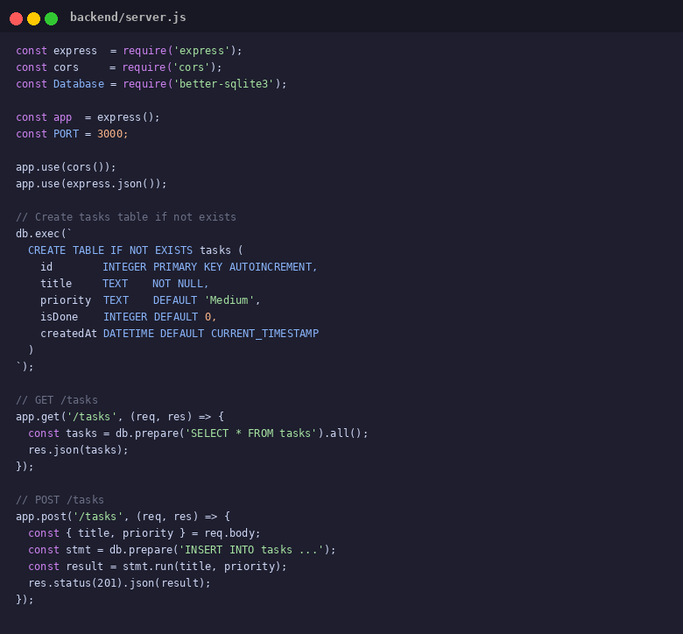
6.2 Frontend — script.js
The frontend uses native fetch() to communicate with the backend API. It includes an addTask() function that validates input (empty check, 50-char limit), a toggleDone() for marking tasks complete, deleteTask(), editTask() with inline editing, renderTasks() with filter/search/sort, and an exportJSON() bonus feature. A LocalStorage fallback is included if the server is not running.

script.js code:
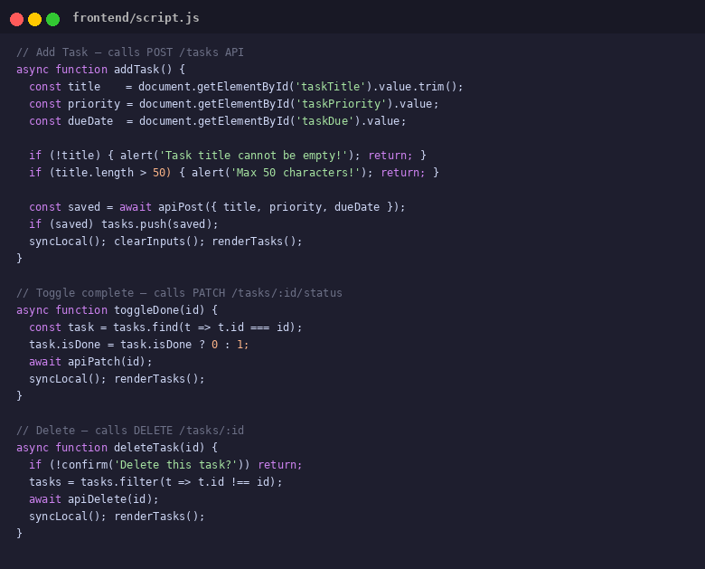

7. Screenshots — Output
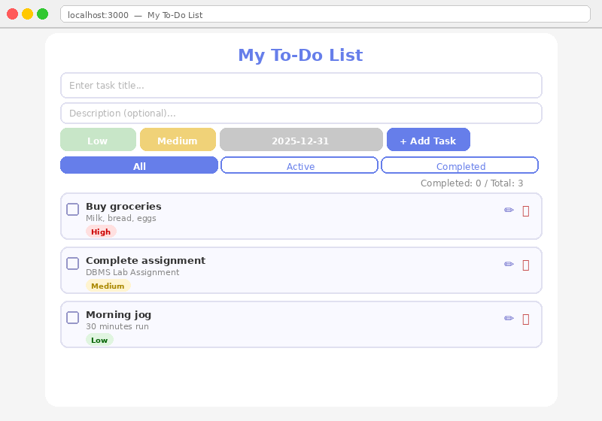
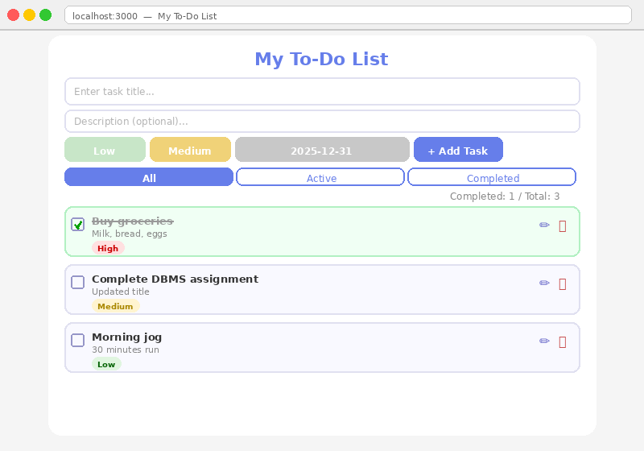
7.3 Completed Filter Applied

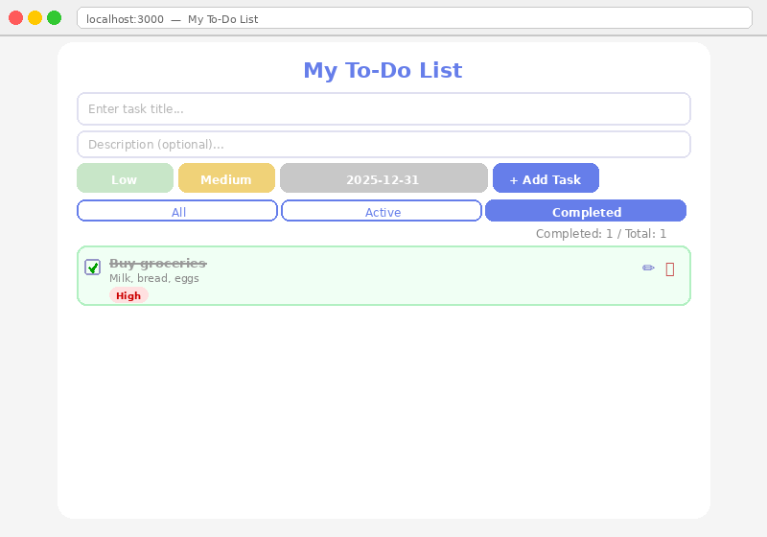
7.4 Bonus — Overdue Highlight
